Assignment 1 – Introduction to Web Development.

➢ Explain the difference between frontend, backend, and full-stack development with suitable real-world examples ?
- 1. Frontend Development (What customers see)
a. Frontend is the part of a website or app that users can see and use.
b. It includes buttons, images, menus, colors, and forms.
Example: On Amazon, the homepage, product images, and the "Add to Cart" button are all part of the frontend.
- 2. Backend Development (Behind the scenes)
a. Backend is the hidden part that does all the important work.
b. It stores data, checks login details, processes payments, and manages orders.
Example: When you place an order on Amazon, the backend checks if the product is in stock, processes your payment, and saves your order.
- 3. Full-Stack Development (Both frontend and backend)
a. A full-stack developer works on both the frontend and the backend.
b. They build the complete website or application from start to finish.
Example: A full-stack developer can create the shopping page, connect it to the database, and make sure orders are saved correctly.
- Easy Real-Life Example (Restaurant)
Frontend: The dining area, menu, and waiter that customers interact with. Backend: The kitchen where the food is prepared.

➢ Create a simple diagram showing how the client-server model works in web architecture ?
- Diagram :
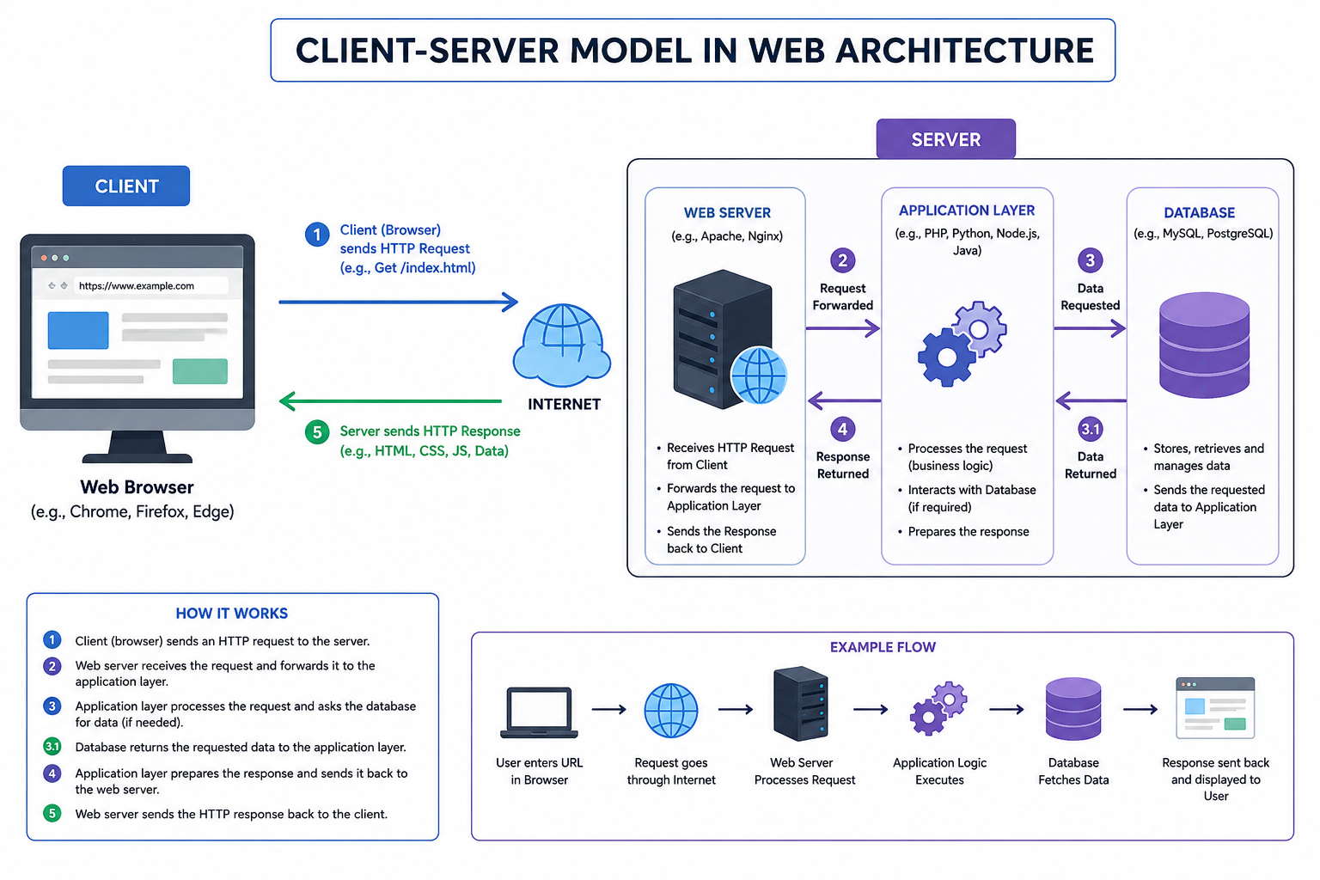
Explanation of the Client–Server Model :
The Client–Server Model is a web architecture in which a client (such as a web browser) sends a request to a server over the internet. The server processes the request, retrieves the required data (if needed), and sends the response back to the client.
Working:
- Client (Browser): The user enters a website URL or clicks a link in the browser.
- HTTP Request: The browser sends an HTTP request to the web server through the Internet.
- Server Processing: The web server receives the request, processes it, and accesses the database if data is required.
- HTTP Response: The server sends the requested webpage or data (HTML, CSS, JavaScript, images, etc.) back to the client.
- Display: The browser displays the webpage to the user.
➢ Describe how a browser requests and displays a web page from a web server ?
Explanation:
The Client–Server Model is a network architecture in which the client requests services, and the server provides them.
Working Process :
- The user enters a website URL in the browser.
- The browser sends an HTTP request to the web server.
- The web server processes the request and communicates with the database if required.
- The database returns the requested information.
- The server sends an HTTP response back to the client.
- The browser renders and displays the webpage.
Advantages :
- Centralized data management
- Better security
- Faster communication
- Easy maintenance
- Supports multiple users simultaneously.

➢ Identify and list the tools required to set up a web development environment. Explain the purpose of each.
A web development environment consists of software tools that help developers write, test, debug, and deploy websites efficiently.
Tool Purpose :
- Visual Studio Code Lightweight source code editor for writing HTML, CSS, JavaScript, and backend code.
- Google Chrome Tests and displays web pages during development.
- Chrome Developer Tools Helps inspect HTML, CSS, JavaScript, and debug web applications.
- Node.js Runs JavaScript outside the browser and supports backend development.
- npm (Node Package Manager) Installs and manages JavaScript libraries and frameworks.
- Git Tracks code changes and supports version control.
- GitHub Stores projects online and enables collaboration among developers.

➢ Explain what a web server is and give examples of commonly used servers ?
A web server is software or hardware responsible for storing, processing, and delivering web pages to users through the HTTP or HTTPS protocol.
When a browser requests a webpage, the web server processes the request and sends the appropriate response.
Functions of a Web Server :
- Receives HTTP/HTTPS requests from clients.
- Processes user requests.
- Retrieves files or database information.
- Sends HTML, CSS, JavaScript, images, and other resources.
- Handles multiple client requests simultaneously.
- Provides website security through HTTPS.

➢ Define the roles of a frontend developer, backend developer, and database administrator in a project ?
A web development project involves different professionals who work together to build a complete application.
- Frontend Developer: Develops the user interface of a website using HTML, CSS, and JavaScript. They ensure the website is attractive, responsive, and easy to use.
- Backend Developer: Builds the server-side logic of the application. They handle user requests, create APIs, manage authentication, and connect the application with the database using technologies like Node.js, Python, or Java.
- Database Administrator (DBA): Manages the database by storing, organizing, securing, and maintaining data. They ensure data is available, accurate, and backed up regularly.
Conclusion: Together, these professionals ensure that a web application is functional, secure, and user-friendly.

➢ Install VS Code and configure it for HTML, CSS, and JavaScript development. Take a screenshot of the setup.
- Download and install Visual Studio Code.
- Open VS Code and install the following extensions:
- Live Server
- Prettier
- HTML CSS Support
- Auto Rename Tag
- Create a project folder with three files:
- index.html
- style.css
- script.js
- Open the project folder in VS Code.
- Right-click index.html and select Open with Live Server to preview the webpage.
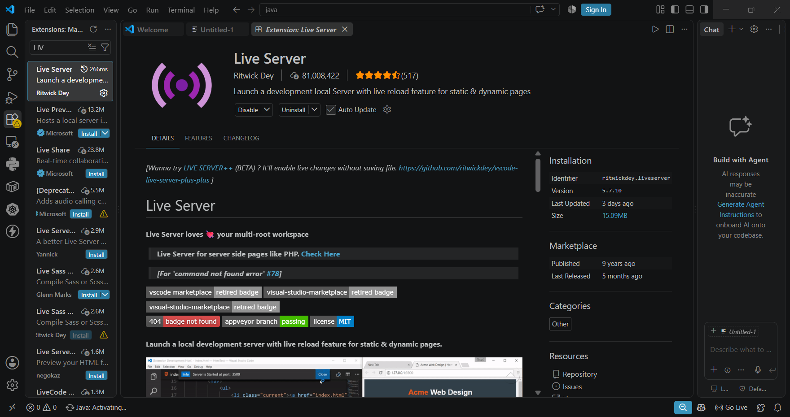

➢ Explain the difference between static and dynamic websites. Provide an example of each ?
A Static Website displays the same content to every visitor. It is built using HTML and CSS, and the content changes only when the developer manually updates the files.
A Dynamic Website generates content based on user requests or data stored in a database. It allows user interaction such as login, registration, and online shopping.
Static Website Dynamic Website
Fixed content Dynamic content
No database Uses a database
Faster More interactive
Easy to develop ->More complex
Examples:
- Static Website: Personal Portfolio
- Dynamic Website: Amazon, Facebook, Instagram

➢ Research and list five web browsers. Explain how rendering engines differ between them ?
The five popular web browsers are Google Chrome, Microsoft Edge, Mozilla Firefox, Apple Safari, and Opera. Chrome, Edge, and Opera use the Blink rendering engine, which is known for speed and compatibility with modern web standards.
Firefox uses the Gecko engine, developed independently by Mozilla, while Safari uses WebKit, which is highly optimized for Apple devices. Different rendering engines interpret HTML, CSS, and JavaScript differently, which may result in slight variations in website appearance and performance.

➢ Draw a labeled diagram showing the basic web architecture flow — client, server, database, and APIs.
Diagram:
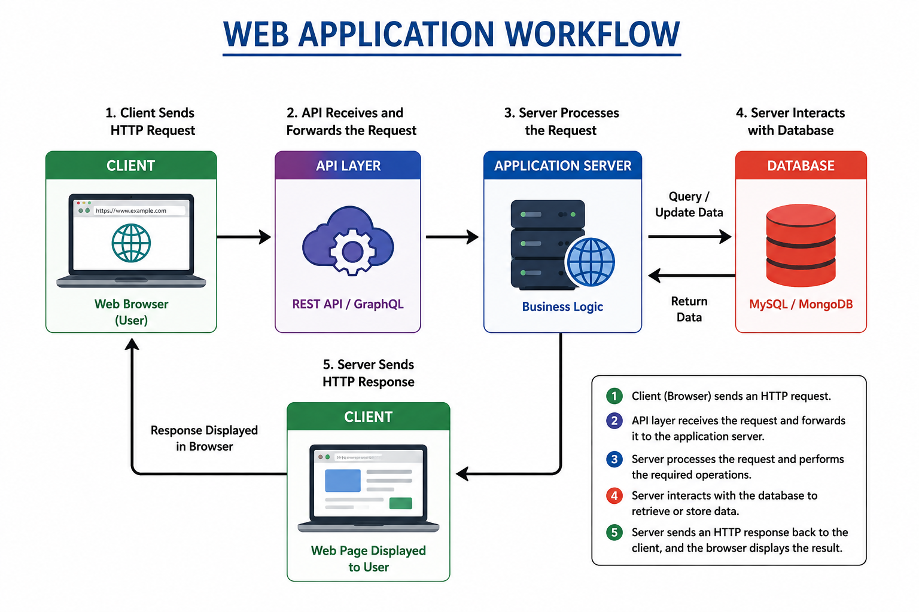
Workflow :
- The Client (Web Browser) sends an HTTP Request.
- The Web API receives the request and forwards it to the Application Server.
- The Application Server processes the request and interacts with the Database.
- The Database returns the required data to the server.
- The Application Server sends an HTTP Response back to the client, and the browser displays the webpage.
MUSKAN KUMARI
END OF PAGE ! SB (38)

